Nocturnal Moths in Xeric Habitats in the Northeast U.S.

Elizabeth Crisfield, Rick Van de Poll, Mark Mello, Helen Poulos, Andrew Barton

Abstract
In 2018, the Northeast Association of Fish and Wildlife Agencies (NEAFWA), through the Northeast Fish and Wildlife Diversity Technical Committee (NEFWDTC) and the Regional Conservation Needs Grant Program, initiated a 5-year project with the objective of improving habitat management of Barrens in the Northeastern U.S. The states funded the “Xeric Habitat for Pollinators” project due to the known concentration of Regional Species of Greatest Conservation Need at barrens sites, including rare Lepidoptera dependent on barrens obligate host plants and other unique habitat conditions. In 2021 and 2022, four lepidopterists visited 20 sites 5 times from May to October and deployed UV traps overnight. The compiled dataset includes 814 macro moths, 627 micro moths, and 6 non-native species. The team identified 88 species closely associated with barrens habitat conditions and found 64 at sites in the Northeast. Moth species associated with xeric habitats, including fourteen Regional Species of Greatest Conservation Need, were identified based on the literature and best professional judgment.

Introduction
In 2018, the Northeast Association of Fish and Wildlife Agencies (NEAFWA) through the Northeast Fish and Wildlife Diversity Technical Committee (NEFWDTC) initiated a 5-year project with the objective of improving habitat management of Xeric Habitats in the Northeastern U.S. The states funded the “Xeric Habitat for Pollinators” project due to the known concentration of Regional Species of Greatest Conservation Need at barrens sites. In particular, several species of rare Lepidoptera were known to be obligates of barrens habitats.
Xeric ecosystems in the northeastern U.S. include pine barrens, sandplain grasslands, heathlands, and other habitats that have sparse vegetation that was historically maintained by frequent fires. These sites contain soils that are typically sandy and well-drained, infertile, and deep (Quigley 2020; Corbin & Flatland 2022). Prior to the modern practice of fire suppression (beginning ~1910), habitat conditions in Northeastern grasslands and barrens were maintained by the physical and chemical properties of their xeric soils, site topography, local climate, and relatively frequent fires (<~20 year fire return interval) with variable severity (Forman and Boerner 1981, Sohl 2003). Because of the small total spatial extent and low connectedness of these xeric habitats in the Northeast, a number of rare species are associated with these sites including several Lepidoptera (Leuenberger et al. 2016).
Barrens habitats in the Northeast U.S. have long been recognized as an important habitat type for moths – fifty-six rare Lepidoptera in Connecticut and Massachusetts were demonstrated to be affiliated with barrens habitats (Wagner et al. 2003). And while host plants are important for reproduction, landscape composition and structure also appears to be important for barrens dependent species (Grand & Mello 2004). A study of scrub oak barrens in Northeast Pennsylvania, with a range of conditions, found 373 species, of which nine were state-listed and four were detected only in restored barrens (Leuenberger et al. 2016).
Several factors contribute to Lepidoptera rarity at xeric sites. First, and perhaps most importantly, above ground vegetation directly support a number of species-specific larval feeders. Scrub oak or oak-pine woodlands include several oak species such as Quercus stellata (post oak) and Quercus ilicifolia (scrub oak) that are primary host plants for many barrens affiliated species (Schweitzer et al. 2018). Pitch pine, bayberry (Myricaceae), New Jersey tea (Ceanothus sp.), and blueberry (Vaccinium) and other Ericaceae are documented host plants of some of the barrens affiliated moth species (Wagner et al. 2003; Robinson et al. 2010; Schweitzer et al. 2018). Vaccinium spp. (lowbush blueberries) are also characteristic in the understory of Pine Barrens or in heathlands (Wagner et al. 2003; Schweitzer et al. 2018). Second, the xeric conditions in these habitats support many ground-dwelling invertebrates requiring loose, bare, sandy soil warmed by sunlight penetrating sparse vegetation (Wagner et al. 2003). Finally, the high diurnal temperature variation due to lack of tree cover, lower humidity, and frost pockets may reduce mortality due to parasitoids (Wagner et al. 2003).
Although an absence of life history information and survey data limit our ability to confidently identify many barrens obligates, several have been long recognized as being only found in xeric habitats. Based on the available literature and the professional judgement of the contracted team, a list of species with likely associations was developed (Appendix A.) These include some of the most well-known barrens associates listed below (Table 1).
Table 1. Species determined to be strong affiliates of xeric habitats in the Northeast U.S. with host plants, phenology, habitat characteristics, and status information.
Species | Host Plant | Flight Time | RSGCN Status | G-rank
Acronicta albarufa | Quercus spp. Especially ilicifolia, prinoides, macrocarpa, stellata | Summer; poss. partial second brood | Watchlist [Assessment Priority] | G3G4
Acronicta dolli | Polyphagous on woody plants | Early Spring | RSGCN – High Concern | G3G4
Agrotis buchholzi | Pyxidanthera barbulata (Flowering pyxie-moss) | Spring through summer | RSGCN – Very High Concern | G2
Apodrepanulatrix liberaria | Ceanothus americanus (New Jersey tea) | Early Fall | RSGCN – High Concern | G3
Catocala herodias | Quercus illicifolia | Summer | RSGCN – High Concern | G3T3
Catocala jair | Quercus spp. | Early Summer |  | G4
Chaetaglaea cerata | Blueberry, black huckleberry, scrub oak, and Prunus spp. | Fall | RSGCN – Very High Concern | G3G4
Crambus daeckellus | Suspected Eastern Turkeybeard | Spring through summer | RSGCN – Very High Concern | G1G3
Cyclophora culicaria | Kalmia buxifolia (Sand myrtle) | Spring through summer | Watchlist [Assessment Priority] | GU
Drasteria occulta | Vaccinium spp. | Early Summer | RSGCN – Very High Concern | G4
Heterocampa varia | At least Quercus ilicifolia and prinoides | Summer | RSGCN – High Concern | G3G4
Hypomecis buchholzaria | bayberry (Myrica sp. Myricaceae), Comptonia peregrina var. asplenifolia | Summer | RSGCN – Moderate Concern | G3G4
Macaria exonerata | Quercus ilicifolia (Scrub Oak) | Summer | RSGCN – Very High Concern | G3G4
Phoberia ingenua (formerly P. orthosioides) | Quercus spp. | Early Spring |  | G3
Zale lunifera | At least Quercus illicifolia and prinoides | May-June | Watchlist [Assessment Priority] | G3G4
Zanclognatha martha | Pitch pine; including dead leaves | Summer | Watchlist [Assessment Priority] | G4

In general, invertebrates are in decline (Wagner 2020) and observations of Lepidoptera decline in the Northeast have been reported for many years (Wagner 2012). Some reasons for these declines include loss of suitable habitats, vegetative succession and changes in vegetative composition (e.g. deer browse), light proliferation, and potentially increased predation from birds and bats (Wagner 2012). Fragmented habitat (sites less than 500-1000 ha) do not support many of the more specialized Lepidoptera (Wagner et al. 2003). Treatment of patches within sites to restore habitat condition helps provide refugia and a population source for recolonization after management activities (Wagner et al. 2003).
In addressing loss of suitable habitat or degradation of habitat condition in xeric habitats, moth diversity can be expected to respond if characteristic vascular plant communities are recovered (Shuey et al. 2012). In determining the optimal patchiness of habitat management mosaics for nocturnal moth resilience to habitat management, it is helpful to consider dispersal distances of moths. For moths, habitat preferences and wing size and shape were found to influence dispersal distances (Slade et al. 2013). In general, moths with large pointed wings and those that fed as adults had larger dispersal distances with the majority predicted to move <500 m/week (Slade et al. 2013). Noctuid moths studied in tethered flight were found to travel 600-12000 meters (Jones et al. 2016), although noctuids are more mobile than geometrid and erebid species (Merckx & Slade 2014). Assuming a common adult dispersal distance of 500 m, sites with management units that create patches < 0.25 km² in size will provide the best opportunity for recolonization of moths following mortality from management.

Methods
The survey results reported here were part of a larger project. Xeric sites from around the northeast that were involved in habitat management were recruited to participate in vegetation, bee and moth surveys. Moth surveys started in the third year of the project and were intended to build on other components, so the locations of the moth traps were determined by the locations where bee surveys had been conducted.
For the field portion of this study, four contractors were chosen to conduct baseline nocturnal trap samples at 18 of the 20 xeric habitat sites used in the associated invertebrate research. Sites were visited five times in 2021 from April to September, with specific dates determined by weather, moon phase, contractor schedule constraints and other factors. To maximize collection, traps were set on nights with little predicted rainfall, low wind speed, high temperature, high humidity, and near a new moon or with heavy cloud cover to limit moonlight. Conditions were recorded for each collection event. In 2022, most sites were revisited five times, however the northernmost sites were visited three times due to the shorter season.
At each site, three 15 W UV bucket traps were placed before sunset and collected after sunrise the following day. Lamps were powered by car batteries and light sensors were used to turn on lamps as needed given site logistics. Traps were armed with an appropriate killing agent (e.g. acetone or ethyl acetate). Buckets were placed at least 100 m apart and co-located with bee bowl transects being run at each site.
All macro-Lepidoptera (SuperFamilies Drepanoidea, Geometroidea, Mimallonoidea, Bombycoidea, Sphingoidea, and Nocuoidea) and five families of micro-Lepidoptera (Limacodidae, Crambidae, Megalopygidae, Zygaenidae, and Tortricidae) were identified to species level, with reference to Hodges checklist and Pohl’s phylogenetic sequence numbers. In 2021, at least one voucher specimen for each species collected at each site was pinned and labeled with the voucher number and scientific name. In 2022, only newly documented species in this project were vouchered. Voucher specimens for sites in New Hampshire are available at the University of New Hampshire Zoological Museum, and in Maine at the Maine Museum. All other sites’ specimens are housed by the Biodiversity Research Collection at the University of Connecticut.
The importance of environmental conditions on moth communities was explored using data from the Soil Survey Geographic Database (SSURGO). Soil organic matter and percent sand were selected to represent differences between sites that may be related to moth communities. Number of frost-free days was used to represent differences in climate zones.

Site Descriptions
The geographic extent of the study area in the Northeastern US comprises humid temperate ecoregions, and site conditions are influenced by differences in climate and topography. Many sites in this study are located near the coast in the Northeastern Coastal Zone, the Atlantic Coastal Pine Barrens, and the Middle Atlantic Coastal Plain (Fig. 1) (US EPA 2015). Inland from these are the sites in the Northeastern Highlands, Ridge and Valley, and Blue Ridge ecoregions.
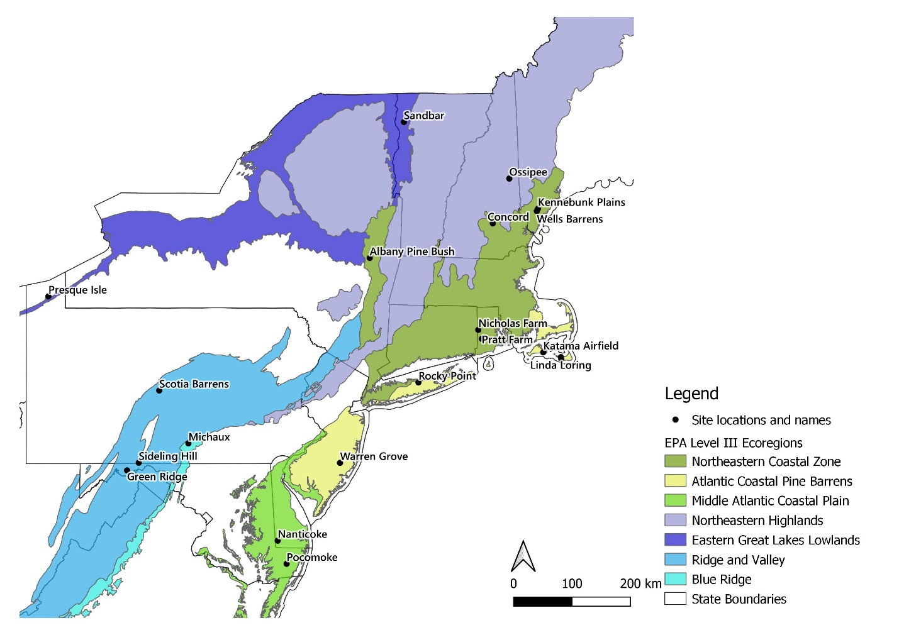
Figure 1. Site locations within ecoregions. Presque Isle and Sandbar were not surveyed for nocturnal moths although they participated in other components of the project.

Sites participating in this project range in size from less than 100 acres to more than 3000 acres and include grasslands, heathlands, scrub oak shrublands, and pitch pine-oak woodlands. Sites vary widely in historic land use, recent management effort, current condition, and compatibility with adjacent lands. To support statistical analysis, sites were categorized simply as grassland or woodland. Sites with little or no management in the decade leading up to this project were classified as “unmanaged” (Table 2).
Table 2. Sites where nocturnal moths were surveyed with habitat type and prior management.
Site, state | Land Manager | Habitat Type | Prior Management | Data Included in this report
EPA Level III Ecoregion: Northeastern Highlands
Ossipee Pine Barrens, New Hampshire | The Nature Conservancy | Woodland | Managed and Unmanaged units | 2021
EPA Level III Ecoregion: Northeastern Coastal Zone
Kennebunk and Wells Barrens, Maine | The Nature Conservancy | Grassland | Managed | 2021, 2022
Concord Pine Barrens, New Hampshire | New Hampshire Fish & Game | Woodland | Managed | 2021, 2022
Albany Pine Bush Preserve, New York | Albany Pine Bush Preserve Commission | Woodland | Managed | 2021, 2022
Nicholas Farm Wildlife Management Area, Rhode Island | Rhode Island Department of Environmental Management | Grassland | Unmanaged | 2021, 2022
Pratt Farm Wildlife Management Area, Rhode Island | Rhode Island Department of Environmental Management | Woodland | Unmanaged | 2021, 2022
EPA Level III Ecoregion: Atlantic Coastal Pine Barrens
Katama, Massachusetts | The Nature Conservancy | Grassland | Managed | 2021, 2022
Linda Loring Nature Foundation, Massachusetts | Linda Loring Nature Foundation | Grassland | Unmanaged | 2021, 2022
Head of the Plains, Nantucket, Massachusetts | Nantucket Conservation Foundation | Grassland | Managed | 2021, 2022
Warren Grove, New Jersey | New Jersey Dept. of Environmental Protection Fish and Wildlife | Woodland | Managed and Unmanaged units | 2021, 2022
EPA Level III Ecoregion: Ridge and Valley
Scotia Barrens, Pennsylvania | PA Game Commission and Patton Township | Woodland / Grassland | Managed | 2021, 2022
Sideling Hill, Pennsylvania | Western Pennsylvania Conservancy | Woodland | Unmanaged | 2021, 2022
Green Ridge State Forest, Maryland | Maryland Dept. of Natural Resources | Grassland | Managed | 2021, 2022
EPA Level III Ecoregion: Blue Ridge
Michaux State Forest, Pennsylvania | Pennsylvania Dept. of Conservation & Natural Resources | Woodland | Managed and Unmanaged units | 2021, 2022
EPA Level III Ecoregion: Middle Atlantic Coastal Plain
Nanticoke Wildlife Area, Delaware | Delaware Dept. of Natural Resources and Environmental Control | Woodland | Unmanaged | 2021, 2022
Pocomoke State Forest, Maryland | Maryland Dept. of Natural Resources | Woodland | Managed | 2021, 2022

Results
As of February 22, 2023, including data documented in Table 2, the project dataset includes identifications of over 61,000 moths representing 814 macro moths, 627 micro moths, and 6 non-native species. These numbers represent all species identified in the dataset, however because of the difficulty in identification of micro moths, only three micro moth families are included in the results presented from this point forward: Limacodidae, Crambidae, and Tortricidae. Three moth families were represented in the greatest abundance, with more than 1000 species: Noctuidae, Geometridae, and Erebidae. Sites with the greatest number of species include Sideling Hill (PA), Scotia Barrens (PA), Albany Pine Bush (NY), and the Nicholas and Pratt Farms (RI) (Fig. 2).
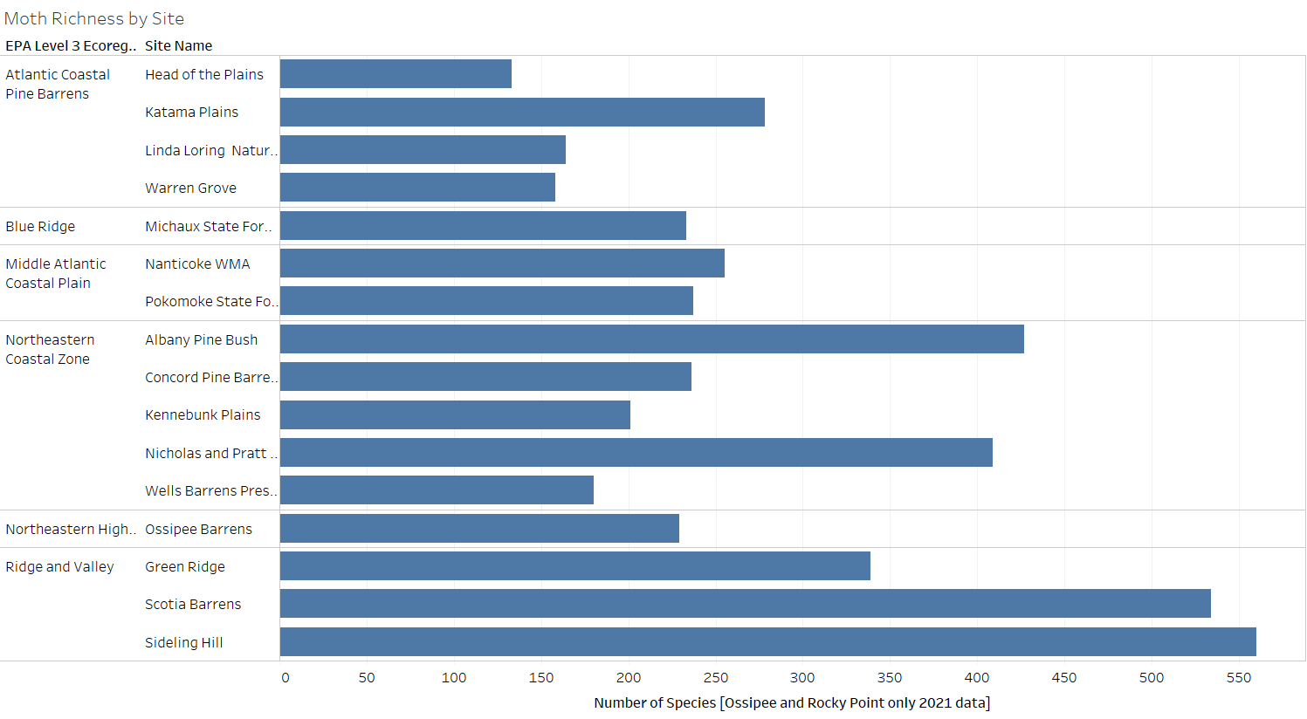
Figure 2. Moth Species Richness by site.
Some very common species were found across most sites. Idia rotundalis was the most abundant species in the dataset with 2,005 records. Eight additional species had 500 records or more. However, the vast majority of species in this dataset had very few observations – 50% macro moths had 10 observations or less. Several of these observations were of interest to states and sites where they were the first known observation (Appendix B).
Total moth abundance differed significantly among sites, across ecoregions, and when comparing woodlands with grasslands. Woodland habitats had significantly higher moth abundance than grassland habitats and Northeastern Highlands, Ridge and Valley, and Blue Ridge ecoregions had greater abundance than the three coastal ecoregions (Fig. 3).
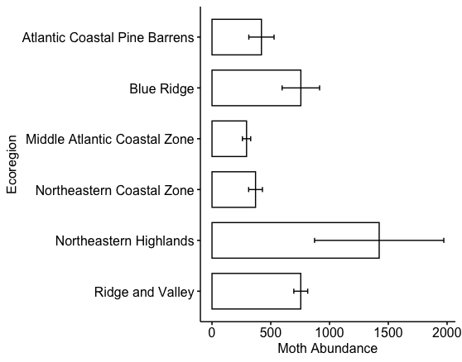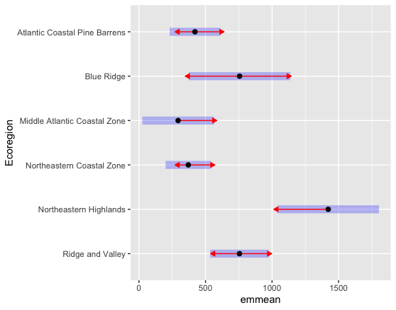
Figure 3. Left: differences in total abundance of moths among ecoregions, with means and 1 SE. Right: Multiple comparisons among ecoregions of abundance, with means and 1 SE (black dot and purple bars). Two ecoregions are significantly different if their red arrows do not overlap.
Species richness and moth communities also differed significantly across the sites and between ecoregions (Fig. 4).
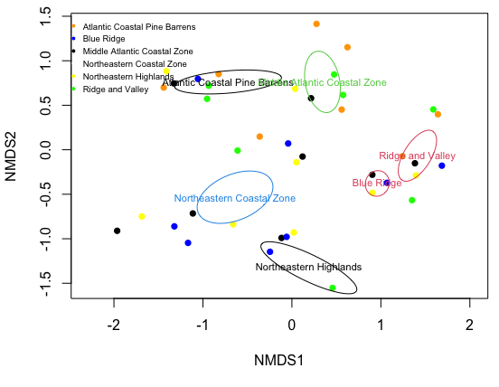
Figure 4. Non-metric multidimensional scaling (NMDS) for 48 moth sample buckets in a suite of units within 17 sites (preserves). The graph shows differences in species composition among buckets along the first two axes. Ellipses show 95% confidence interval for ecoregions, each of which includes multiple sites. Non-overlapping ellipses signify large differences between vegetation types. Colors of ellipses match those of ecoregion names.
Moth abundance and diversity were positively correlated with canopy cover and negatively correlated with the sand fraction of the soil and the number of frost free days. These environmental conditions along with precipitation explained differences in moth communities. In fact, sites that were previously managed, in most cases to reduce woody percent cover, had lower moth abundance and species richness although evenness and diversity were not significantly different.

Barrens Associated Moths
Of the sixteen species determined during the literature review to be strong barrens obligates (Table 1), ten species were documented at the 16 sites (Table 3).
Table 3. Strong xeric obligates observed at project sites.
Species | Total number found | Sites occupied
Acronicta albarufa | 0
Acronicta dolli | 0
Agrotis buchholzi | 2* | Warren Grove, NJ
Apodrepanulatrix liberaria | 41 | Albany Pine Bush Preserve, NY
Catocala herodias | 0
Catocala jair | 0
Chaetaglaea cerata | 3 | Head of the Plains, MA
Crambus daeckellus | 0
Cyclophora culicaria | 33 | Warren Grove, NJ
Drasteria occulta | 71 | Wells Barrens and Kennebunk Plains, ME, Linda Loring Nature Foundation and Head of the Plains, MA, Ossipee Pine Barrens, NH
Heterocampa varia | 74 | Katama Plains and Head of the Plains, MA
Hypomecis buchholzaria | 0
Macaria exonerata | 55 | Albany Pine Bush Preserve, NY, Concord Pine Barrens, NH, Nanticoke WMA, DE
Phoberia ingenua (formerly P. orthosioides) | 6 | Warren Grove, NJ
Zale lunifera | 1 | Concord Pine Barrens, NH
Zanclognatha martha | 95 | Ossipee Pine Barrens, NH, Albany Pine Bush Preserve, NY, Warren Grove, NJ, Nicholas and Pratt Farm, RI, Sideling Hill, PA, Kennebunk Plains, ME
*uncertain identification
Considering the longer list of xeric associated species (Appendix A), the most abundant barrens associate is Gabara subnivosella (657), found at nine sites and considered an indicator species for xeric grasslands and sites in the Atlantic Coastal Pine Barrens (Appendix C). Hyperstrotia flaviguttata, Cisthene packardii, and Catocala badia were all observed more than 100 times at five, eight, and three sites, respectively. Katama Plains had the largest abundance of xeric associated moths (696 specimens) and the largest number of xeric associated species (26).
While some species were found across most sites and had large collections, others were found in only one or two sites but were nonetheless fairly abundant. Apodrepanulatrix liberaria, a barrens obligate and High Concern RSGCN was only collected at Albany Pine Bush Preserve, with 41 specimens. Cyclophora culicaria, a Northeast Assessment Priority species, had 33 records at Warren Grove, but that was the only site where it was observed. Heterocampa varia, a barrens obligate, had a large collection of 74 individuals at only two sites (Head of the Plains and Katama Plains).

Regional Species of Greatest Conservation Need
Nineteen species in the xeric dataset are recognized as Regional Species of Greatest Conservation Need or Assessment Priorities in the Northeast Region (Table 4). Most observations of RSGCN were in the Northeastern Coastal Zone and Atlantic Coastal Pine Barrens Ecoregions. However, Abagrotis benjamini was observed in the greatest abundance in the Blue Ridge Ecoregion (Michaux State Forest) and Plagodis kuetzingi was only observed at sites in the Ridge and Valley Ecoregion.

Table 4. Regional Priority species observed at xeric sites.
Species | RSGCN Status | Xeric Association | Abundance Recorded | Number of Sites
Abagrotis benjamini | High Concern | Beaches | 74 | 4
Apodrepanulatrix liberaria | High Concern | Strong association with xeric sites | 41 | 1
Cerma cora | Assessment Priority | Xeric sites in the Northeast region, but generalist elsewhere | 1 | 1
Chaetaglaea cerata | Very High Concern | Strong association with xeric sites | 3 | 1
Chytonix sensilis | Assessment Priority | Fire associated | 3 | 1
Cyclophora culicaria | Assessment Priority | Strong association with xeric sites | 33 | 1
Drasteria occulta | Very High Concern | Strong association with xeric sites | 71 | 5
Erastria coloraria | High Concern | Associated with xeric sites | 2 | 1
Eucoptocnemis fimbriaris | Assessment Priority | Associated with xeric sites | 3 | 3
Glena cognataria | Assessment Priority |  | 90 | 6
Heterocampa varia | High Concern | Strong association with xeric sites | 74 | 2
Macaria exonerata | Very High Concern | Strong association with xeric sites | 55 | 3
Metarranthis pilosaria | High Concern | Associated with xeric sites | 13 | 1
Phoberia ingenua | Assessment Priority |  | 6 | 1
Plagodis kuetzingi | Assessment Priority |  | 12 | 2
Psectraglaea carnosa | Assessment Priority | Prefer xeric sites | 62 | 4
Schinia septentrionalis | Assessment Priority | Prefer xeric sites | 39 | 4
Zale lunifera | Assessment Priority | Strong association with xeric sites | 1 | 1
Zanclognatha martha | Assessment Priority | Strong association with xeric sites | 95* | 6
*Zanclognatha martha had a strong collection at the Ossipee Pine Barrens in data that was not available in time for the analysis presented in this report. This abundance will increase in future publications.

Discussion
This dataset represents a substantial contribution to the understanding of species habitat associations and ranges and provides a baseline for future surveys. However, there are a number of important factors to consider when interpreting these results. While surveyors tried to visit sites on dates with equivalent weather and light conditions, it is not always possible to adjust logistics. It is also important to understand that a 2-year study, especially one with a sampling frequency of only once per month, is not expected to detect all species present, and light traps do not attract all species.
The geographic breadth and the corresponding diversity of environmental variables including climate and soil appear to explain much of the observed difference in moth communities between the sites making it somewhat difficult to relate management activities to moth diversity and abundance. Much of the difference between sites is likely related to the difference in vegetation communities. Sites and ecoregions with more trees had higher abundance and diversity of moths. Many xeric associated moth species have hostplant requirements that include tree species like oaks and pines. Whereas these canopy species were commonly shared among sites, understory species, particularly ones with specific associations with certain moth species, were quite different. For selected species like Apodrepanulatrix liberaria and New Jersey Tea this can be a strong indicator of which management activities to target, yet for many moth species whose life histories are unknown, this can be quite challenging.
Of the 16 barrens obligate moth species, six were not observed. (Table 3). Acronicta dolli may have an early spring flight period, which could explain why it was not collected during this study. Acronicta albarufa, Catocala jair, and Catocala herodias should have been found based on geographic range, phenology, and habitat affiliation. Crambus daeckellus is a very rare species with few observations over the past 100 years. A more intensive survey effort may be needed to detect that species.
In repeated and lengthy discussions to develop consensus around the xeric-associated moth species, 15 species were determined to be xeric-associated in the Northeastern U.S. but were known from a wider range of habitats in the southeast, midwestern, and even western states. Xeric habitats in the Northeast represent the northern edge of range for some of these species. In the context of climate change driven range shifts, species that are xeric-associated in the Northeast (Appendix A) may represent advance dispersal and serve as a source population for stronger establishment in the future (Wagner 2012). Also, if the larval hostplant is present, coastal tertiary dunes provide an alternate xeric habitat for at least four RSGCN species: Abagrotis benjamini, Drasteria occulta, Glena cognataria and Schinia septentrionalis (Mello, pers. data).
Limitations on the ability to collect micro Lepidoptera in good condition and correct identification by the collectors presented a challenging constraint during this survey. For these reasons, microleps were underreported and understudied in general. There are, however, many species obligates in xeric habitats whose host plant affinities make these habitats essential in their life cycle and therefore are important places to continue research work.
While the broad survey effort was insufficient to statistically analyze the impact of habitat management on moth abundance or diversity over years, prescribed fire at the Albany Pine Bush Preserve provided an opportunity to document moth abundance and diversity during the summer following the burn. Alley Cat unit burned the day the moth trap was set in May, and Bivy unit burned the day before, while Greentaxis unit was a scrub oak-dominated barrens that was unmanaged over the past several years. Over the following 5 sampling windows, species abundance and diversity was not negatively impacted by the fire at Alley Cat and Bivy (Fig. 5). The Albany Pine Bush Preserve follows best practices of management rotation so moths from Alley Cat and Bivy may have utilized nearby untreated management units as refugia, or may have been recolonized from adjacent untreated units.
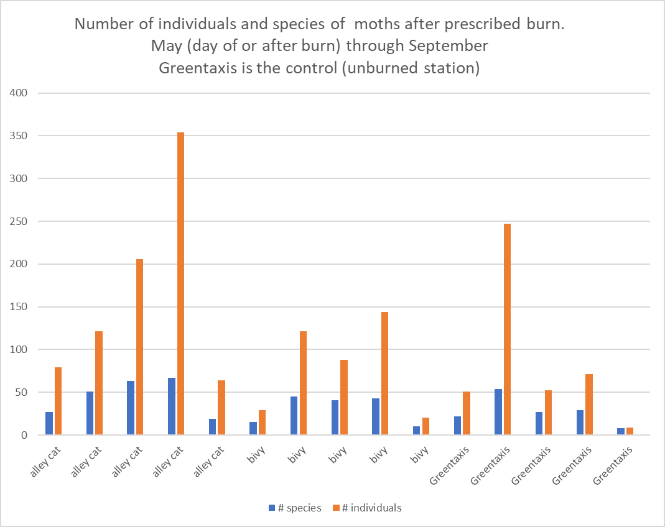
Figure 5. Diversity and abundance of moths at three units in the Albany Pine Bush Preserve, for 5 sampling dates each (May, June, July, August, and September). Alley cat and Bivy management units were burned the day of and the day before (respectively) the first sampling event, while Greentaxis had no management.

Acknowledgments
The authors would like to acknowledge collaborators that identified moths for this project including Sven Strnad, Paul Dennehy, Steve Johnson, and Neil Schoppman. In addition, we were assisted with trapping by Sarah Lindsay, Shannon Marvel McNaught, Libby Buck, Sarah Bois, Seth Engelbourg, Luke MacKay, Hannah Mosier, Danielle O’Dell, Neil Foley and Michael Crawford. We also want to thank Jason Dombrowski (Cornell U.) for receiving micro-moths we could not identify, and Katrina Menard (U. of Connecticut) for receiving moth voucher specimens.
The Xeric Habitats for Pollinators project was supported by State Wildlife Grant funding awarded through the Northeast Regional Conservation Needs (RCN) Program. The RCN Program joins thirteen northeast states, the District of Columbia, and the U.S. Fish and Wildlife Service in a partnership to address landscape-scale, regional wildlife conservation issues. Progress on these regional issues is achieved through combining resources, leveraging funds, and prioritizing conservation actions identified in the State Wildlife Action Plans. See rcngrants.org for more information. We are grateful for the grant management support of Meghan Gilbert and Scot Williamson at the Wildlife Management Institute.

Literature Cited

Barton AM, Poulos HM. 2023. Final Analytical Report: Xeric Habitats Conservation Project. Page 88 pp.
Corbin JD, Flatland EL. 2022. Mapping edaphic soils’ conditions to identify conservation targets for pine barren and sandplain ecosystems in New York State. Ecology and Evolution 12. Available from https://onlinelibrary.wiley.com/doi/10.1002/ece3.9282 (accessed September 15, 2022).
Grand J, Mello MJ. 2004. A multi-scale analysis of species–environment relationships: rare moths in a pitch pine–scrub oak (Pinus rigida–Quercus ilicifolia) community. Biological Conservation 119:495–506.
Jones HBC, Lim KS, Bell JR, Hill JK, Chapman JW. 2016. Quantifying interspecific variation in dispersal ability of noctuid moths using an advanced tethered flight technique. Ecology and Evolution 6:181–190.
Leuenberger W, Bearer S, Duchamp J, Johnson S, Leppo B, McElhenny P, Larkin J. 2016. A Comparison of Lepidoptera Communities Inhabiting Restored and Late Successional Pitch Pine—Scrub Oak Barrens in Pennsylvania. Natural Areas Journal 36:38–47. Natural Areas Association.
Merckx T, Slade EM. 2014. Macro-moth families differ in their attraction to light: implications for light-trap monitoring programmes. Insect Conservation and Diversity 7:453–461.
Quigley K. 2020. Restoring Pine Barrens Habitat: Optimizing Soil Conditions with Prescribed Fire. Page 2. 3, Rooted in Research. Northern Research Station, Forest Service, USDA.
Robinson GS, Ackery PR, Kitching IJ, Beccaloni GW, Hernandez LM. 2010. HOSTS - a Database of the World’s Lepidopteran Hostplants. Natural History Museum, London, UK. Available from http://www.nhm.ac.uk/hosts.
Schweitzer DF, Minno MC, Wagner DL. 2018. Rare, declining, and poorly known butterflies and moths (Lepidoptera) of forests and woodlands in the Eastern United States2nd Edition. U.S. Forest Service, Forest Health Technology Enterprise Team.
Shuey JA, Metzler EH, Tungesvick K. 2012. Moth Communities Correspond with Plant Communities in Midwestern (Indiana, USA) Sand Prairies and Oak Barrens and Their Degradation Endpoints. The American Midland Naturalist 167:273–284. University of Notre Dame.
Slade EM, Merckx T, Riutta T, Bebber DP, Redhead D, Riordan P, Macdonald DW. 2013. Life-history traits and landscape characteristics predict macro-moth responses to forest fragmentation. Ecology 94:1519–1530.
US EPA O. 2015, November 25. Level III and IV Ecoregions of the Continental United States. Available from https://www.epa.gov/eco-research/level-iii-and-iv-ecoregions-continental-united-states (accessed January 3, 2023).
Wagner DL. 2012. Moth decline in the Northeastern United States. News of the Lepidopterists’ Society 54:52–56.
Wagner DL. 2020. Insect Declines in the Anthropocene. Annual Review of Entomology 65:457–480. Annual Reviews.
Wagner DL, Nelson MW, Schweitzer DF. 2003. Shrubland Lepidoptera of southern New England and southeastern New York: ecology, conservation, and management. Forest Ecology and Management 185:95–112.

Appendix A
Barrens associate abbreviations:
- Xeric* - species highlighted in Table X, these are the species believed to be obligate to the xeric habitats studied in this project
- Xeric – species likely to be strongly associated with these habitats
- Prefer xeric – species that can be found in other habitats, but appear to prefer the conditions in habitats studied in this project
- Xeric in the NE – species that may be habitat generalists in other regions, but are only observed in xeric sites in the Northeast.
- Fire – species is associated with fire-adapted habitats
- Early successional – species is associated with early successional habitats

Scientific Name | Xeric associate | host plant | Number found | RSGCN
Abagrotis brunneipennis | Prefer xeric | Vaccinium spp. (Wagner 2003) | 16
Acronicta albarufa | Xeric* | Quercus ilicifolia, possibly other Quercus spp. (Wagner 2003) | 0 | Watchlist [Assessment Priority]
Acronicta dolli | Xeric* |  | 0 | Very HIgh
Acronicta lanceolaria | Prefer xeric | Polyphagous | 0
Acronicta tritona | Prefer xeric | Ericaceae - Wagner et al. 2011 | 45
Agrotis buchholzi | Xeric* |  | 2 | Very HIgh
Amolita roseola | Prefer xeric | Pensylvania sedge - Wagner et al. 2011 | 41
Anacampsis lupinella | Xeric | Lupinus perennis | 0
Apamea burgessi | Prefer xeric | grasses? | 27
Apamea inordinata | Prefer xeric | likely grasses - poss. Beachgrass | 36
Apantesis anna | Xeric in NE |  | 17
Apodrepanulatrix liberaria | Xeric* | New Jersey tea - MANHESP fact sheet & Wagner 2003 | 41 | High
Catocala badia | Prefer xeric | small bayberry - pers. Observation + Myrica spp. Esp. M pensylvanica | 102
Catocala herodias | Xeric* | Quercus ilicifolia, Wagner 2003 | 0
Catocala jair | Xeric* | Quercus ilicifolia, Wagner 2003 | 0
Cerma cora | Xeric in NE | Quercus ilicifolia, Wagner 2003 | 1 | Watchlist [Assessment Priority]
Chaetaglaea cerata | Xeric* | polyphagous? Wagner 2003 black huckleberry (Mello obs. | 3 | Very High
Chaetaglaea rhonda | Prefer xeric | lowbush blueberry and huckleberry - Wagner et al. 2011 | 33
Chaetaglaea tremula | Prefer xeric | polyphagous? Wagner 2003 | 6
Chytonix sensilis | Fire | fungus? Poria? Wagner 2003 | 3 | Watchlist [Assessment Priority]
Cicinnus melsheimeri | Xeric in NE | Quercus ilicifolia, Wagner 2003 | 1
Cingilia catenaria | Early successional | Polyphagous, Wagner 2003 | 20
Cisthene packardii | Xeric in NE | Probably lichens | 131
Cleora projecta | Xeric | Myricaceae, Myrica gale (HOSTS database) | 1
Coelodasys (="Schizura") apicalis | Prefer xeric | bayberry, blueberry, poplar, willow and likely sweet-fern - Schweitzer, et al. 2011 | 17
Crambidia xanthocorpa | Xeric | Probably lichens on trees | 72
Crambus braunellus | Xeric |  | 0
Crambus daeckellus | Xeric* | suspected Eastern Turkeybeard (Xerophyllum asphodeloides) (roots) | 0 | Very High
Cucullia speyeri | Early successional | various Asteraceae - Wagner 2011 - wait, or NJ tea? | 5
Cyclophora culicaria | Xeric* | sand myrtle | 33 | Watchlist [Assessment Priority]
Cycnia collaris | Prefer xeric | orange milkweed | 13
Dasychira pinicola | Xeric in NE | Pitch pine in Massachusetts at least | 6
Dasylophia anguina | Xeric in NE | polypagous, but mainly wild indigo northward - Miller et al. (confirmed at Katama - per.obs.) | 39
Datana contracta | Xeric in NE | Quercus spp. | 8
Datana ranaeceps | Fire | Ericaceae, Lyonia mariana and Vaccinium stamineum (HOSTS Database) | 0
Drasteria graphica atlantica | Xeric | hudsonia (beach heather) Cistaceae, golden heather, pverty grass, evergreen shrub (20 cm tall) | 26
Drasteria occulta | Xeric* | Vaccinium spp. (Wagner 2003) | 71 | Very High
Eacles imperialis | Xeric in NE | pitch pine, post oak - pers. observation | 25
Episemasia solitaria | Prefer xeric | Amer. Holly (Ilex opaca) | 0
Erastria coloraria | Xeric | New Jersey tea (Ceanothus americanus and C. herbaceus) (Wagner 2003) | 2 | High
Euchlaena madusaria | Prefer xeric | lowbush blueberry spp. - MANHESP fact sheet | 50
Eucoptocnemis fimbriaris | Xeric / early successional |  | 3 |  |  | Watchlist [Assessment Priority]
Eueretagrotis attentus | Xeric / early successional | Vaccinium spp. (Wagner 2003) | 20
Eumacaria madopata | Prefer xeric | pin and sand cherry - Wagner, et al.2001 | 28
Euxoa perpolita | Prefer xeric | unknown - probably grasses and/or herbs | 33
Euxoa violaris | Prefer xeric | unknown - probably grasses and/or herbs | 32
Feltia manifesta | Xeric | unknown - probably grasses and/or herbs | 15
Gabara subnivosella | Xeric | Grasses (Robinson et al., 2002) | 657
Hemaris gracilis | Prefer xeric | Vaccinium spp. | 0 | Watchlist [Assessment Priority]
Hemileuca maia | Xeric in NE | Quercus spp., esp. Q. ilicifolia and Q. prinoides, and rarely Q. velutina (Wagner 2003) | 0
Hemileuca maia ssp. 5 | Xeric |  | 0
Heterocampa varia | Xeric* | scrub and dwarf scrub oak - pers. observation (Q. ilicifolia Wagner 2003) | 74 | High
Hyparpax aurora | Xeric in NE | oaks, scrub oak northward - Miller et al., 2021 | 15
Hyperstrotia flaviguttata | Xeric in NE | oak (in barrens northward) - Wagner et al. 2011 | 241
Hypomecis buchholzaria | Xeric* | bayberry (Myrica sp. Myricaceae), Comptonia peregrina var. asplenifolia (see Wagner 2003) | 0 | Moderate
Inguromorpha basalis | Prefer xeric |  | 0
Lapara coniferarum | Xeric in NE | pitch pine - Wagner 2005 | 97
Lycia rachelae | Prefer xeric | undocumented, probably polyphagous (Wagner 2003) | 0 | Watchlist [Assessment Priority]
Lycia ypsilon | Xeric in NE | undocumented, polyphagous southward (Wagner 2003) | 0
Macaria exonerata | Xeric* | scrub oak - Nelson, pers. comm. | 55 | Very High
Megalopyge crispata | Prefer xeric | coastal bayberry, lowbush blueberry - pers. observation | 666
Meropleon ambifusca | Early successional | big bluestem grass (Andropogon ambifusca) - Quinter, pers. comm. | 24
Metarranthis apiciaria | Prefer xeric | undocumented (Wagner 2003) | 0 | High
Metarranthis near lateritearia | Xeric |  | 0
Metarranthis pilosaria | Xeric | probably Ericaceae | 13 | High
Morrisonia mucens | Xeric in NE | Quercus spp., including Q. ilicifolia (Wagner 2003) | 2
Nepytia pellucidaria | Prefer xeric | pitch and shortleaf pine | 11
Pelochrista adamantana | Prefer xeric | other species of Pelochrista are documented on Compositae | 3
Phoberia ingenua (formerly P. orthosioides) | Xeric* | Quercus spp., including Q. ilicifolia (Wagner 2003) | 11
Photedes carterae | Xeric |  | 0 | Very High
Properigea costa | Xeric |  | 25
Psectraglaea carnosa | Prefer xeric | undocumented (Wagner 2003) | 62 | Watchlist [Assessment Priority]
Schinia lynx | Prefer xeric |  | 0
Schinia septentrionalis | Prefer xeric | stiff aster and showy aster - Wagner et al. - 2011 | 39 | Watchlist [Assessment Priority]
Schinia spinosae | Prefer xeric |  | 0
Schizura apicalis | Prefer xeric | undocumented (Wagner 2003) | 17 | Watchlist [Assessment Priority]
Sideridis maryx | Xeric | polyphagous on herbs - Forbes, 1954 (undocumented, probably vaccinium spp. Wagner 2003) | 90
Sideridis rosea | Prefer xeric |  | 36
Spilosoma dubia | Prefer xeric | polyphagous on herbaceous plants | 72
Spinitibia hodgesi | Prefer xeric |  | 0
Stenaspilatodes antidiscaria | Xeric | possibly sand myrtle | 7
Sympistis dentata | Prefer xeric | lowbush blueberries and bog laurel - Wagner et al. 2011 | 44
Sympistis riparia | Prefer xeric | beach plum -Nelson & Goldstein 2015 | 1
Syngrapha epigaea | Early successional | Vaccinium spp. Wagner 2003 | 1
Xestia elimata | Xeric in NE | pitch pine - Wagner 2011 | 75
Xylena cineritia | Prefer xeric | polyphagous (Wagner 2003) | 0
Xylena thoracica | Prefer xeric | Undocumented;but probably polyphagous (Wagner 2003) | 1
Xylotype capax | Xeric | Undocumented;but probably polyphagous (Wagner 2003) | 2
Zale buchholzi | Xeric |  | 2
Zale curema | Xeric | pitch pine - Wagner et al. 2011 | 9
Zale lunifera | Xeric* | Quercus illicifolia (Wagner 2003) | 1 | Watchlist [Assessment Priority]
Zale squamularis | Prefer xeric | Pinus spp. | 10
Zale submediana | Xeric | pitch pine - Wagner et al. 2011 | 6
Zanclognatha martha | Xeric* | Undocumented, but probably plant detritus; captive larvae accepte dead leaves (Wagner 2003) | 95 | Watchlist [Assessment Priority]

Appendix B
Notable observations of rare species:
- Properigea costa – new record at Sideling Hill, Pennsylvania, not observed since 1988.
- Deidamia inscriptum – This species had not been observed in Delaware in quite some time (Jason Davis, personal communication)
- Tolype notialis – This species had not been observed in Delaware in quite some time (Jason Davis, personal communication)
- Sitochroa dasconalis - Found at Scotia Pine Barrens, possibly a wild indigo specialist that is hanging on along with Frosted Elfin at the site, Pennsylvania state record
- Arcutelphusa talladega – New Hampshire state record: Found at Ossipee.
- Acronicta clarescens – new record at Concord Pine Barrens
- Acronicta lanceolaria - new recent record at Concord Pine Barrens, previously observed in 1994 by Van Luven
- Litholomia napaea - new record at Concord Pine Barrens
- Lithophane pexata - new record at Concord Pine Barrens
- Psectraglaea carnosa – rediscovered in Maine after several decades absence
- Erastria coloraria – species is nearly absent in the Northeast but was found at Albany Pine Bush. Hostplant is New Jersey Tea.
- Glenoides texanaria – possibly expanding range northward
- Leucania rubripennis – possibly expanding range northward
- Striacosta albicosta – pest of bean crops, possibly expanding range eastward
- Zanclognatha martha – many new observations of this RSGCN barrens obligate at Ossipee Pine Barrens.

Appendix C
Table B1. Indicator species analysis of NMDS of moth species composition by ecoregion. The lists show moth species that occur statistically significantly more often in one ecoregion type than others. Species are listed in descending order of the strength of the association with each group. Indicator species analysis is described in the Methods box above. (reprinted from (Barton & Poulos 2023)
ATLANTIC COASTAL PINE BARRENS | Statistic |  | Statistic
Gabara.subnivosella | 0.864** | Crambus.saltuellus | 0.855**
Chaetaglaea.rhonda | 0.813*** | Sparganothis.unifasciana | 0.854**
Sphinx.gordius | 0.763* | Anageshna.primordialis | 0.845**
Euchlaena.serrata | 0.71* | Lycophotia.phyllophora | 0.845**
Agrotis.vetusta | 0.645* | Renia.sobrialis | 0.838**
Apamea.inordinata | 0.645* | Dasychira.obliquata | 0.836**
Cingilia.catenaria | 0.645* | Apamea.amputatrix | 0.816**
Euxoa.violaris | 0.645* | Dyspyralis.nigellus | 0.816**
Spilosoma.dubia | 0.645* | Elophila.icciusalis | 0.816**
Abagrotis.benjamini | 0.577* | Eueretagrotis.attentus | 0.816**
Catocala.badia | 0.577* | Eulithis.explanata | 0.816**
Euxoa.detersa | 0.577* | Macaria.brunneata | 0.816**
Feltia.manifesta | 0.577* | Macrochilo.absorptalis | 0.816**
Heterocampa.varia | 0.577* | Nepytia.pellucidaria | 0.816**
Papaipema.baptisiae | 0.577* | Phtheochroa.riscana | 0.816**
 |  | Scoparia.penumbralis | 0.816**
BLUE RIDGE |  | Choristoneura.pinus | 0.812**
Fishia.illocata | 0.997*** | Malacosoma.disstria | 0.806**
Metaxaglaea.viatica.M..semitaria | 0.994*** | Crambus.agitatellus | 0.806***
Syndemis.afflictana | 0.988*** | Retinia.gemistrigulana | 0.804**
Argyrotaenia.mariana | 0.974*** | Hypagyrtis.piniata | 0.802**
Darapsa.choerilus | 0.973*** | Sparganothis.tristriata | 0.797**
Phosphila.turbulenta | 0.973** | Acleris.curvalana | 0.795**
Chaetaglaea.sericea | 0.968*** | Hypenodes.caducus | 0.791**
Allotria.elonympha | 0.942*** | Choristoneura.rosaceana | 0.787**
Sunira.bicolorago | 0.93** | Phalaenostola.metonalis | 0.786**
Pero.ancetaria,honestaria, morrisonaria | 0.903** | Argyrotaenia.velutinana | 0.784**
Idia.aemula | 0.856** | Balsa.tristrigella | 0.778**
Heterocampa.obliqua | 0.827** | Dasychira.plagiata | 0.77*
Orthimella.fidelis | 0.795** | Symmerista.canicosta | 0.768*
Antepione.thisoaria | 0.791** | Macaria.pinistrobata | 0.76***
Spiramater.lutra | 0.739* | Loxostegopsis.merrickalis | 0.745**
Leucania.adjuta | 0.735* | Retinia.comstockiana | 0.745**
Ectropis.crepuscularia | 0.734* | Nematocampa.resistaria | 0.741**
Euchlaena.marginaria | 0.732* | Macaria.bisignata | 0.736**
Artace.cribrarius | 0.726* | Callopistria.cordata | 0.732**
Orthosia.revicta | 0.725* | Glena.cribrataria | 0.713*
Chytolita.morbidalis | 0.72* | Hyphantria.cunea | 0.707*
Paonias.astylus | 0.71* | Neodactria.caliginosellus | 0.703*
Morrisonia.evicta | 0.703*
Meganola.minuscula | 0.698* | RIDGE AND VALLEY
Pyrefedagrra.hesperio | 0.632* | Lomographa.glomeraria | 0.925**
 |  | Ianassa.lignicolor | 0.912***
MIDDLE ATLANTIC COASTAL |  | Desmia.funeralis | 0.904***
Hypagyrtis.esther | 0.969*** | Catocala.amica.C..lineella | 0.882**
Hypagyrtis.unipunctata | 0.946*** | Apantesis.phalerata,vittate,nais,carlotta | 0.877**
Cisthene.packardii | 0.865** | Clemensia.albata | 0.869**
Crambidia.uniformis | 0.834** | Acronicta.hasta | 0.864**
Idia.rotundalis.complex | 0.707* | Choephora.fungorum | 0.816**
Tolype.notialis | 0.707* | Eudryas.grata | 0.816**
Costaconvexa.centrostrigaria | 0.678* | Haploa.contigua | 0.816**
Cisthene.subjecta | 0.577* | Pantographa.limata | 0.816**
Hypena.manalis | 0.577* | Parasa.chloris | 0.816**
Bleptina.inferior | 0.544* | Leucania.linda | 0.796**
 |  | Mocis.texana | 0.795**
NORTHEASTERN COASTAL |  | Agnorisma.badinodis | 0.787**
Clepsis.peritana | 0.856** | Tolype.velleda | 0.779**
Ancylis.spiraeifoliana | 0.73** | Panopoda.carneicosta | 0.769**
Hypenodes.fractilinea | 0.73* | Acronicta.retardata | 0.756*
Polia.purpurissata | 0.73* | Cosmia.calami | 0.749**
Agriphila.ruricolellus | 0.689* | Catocala.vidua | 0.745*
Aethalura.intertexta | 0.685* | Clostera.albosigma | 0.745*
Apotomis.albeolana | 0.632* | Melanolophia.signataria | 0.68*
Eucosma.parmatana | 0.632* | Baileya.levitans | 0.667*
Rhyacionia.rigidana | 0.632* | Catocala.retecta | 0.667*
Spaelotis.clandestina | 0.632* | Crambidia.cephalica | 0.667*
 |  | Pagara.simplex | 0.667*
NORTHEASTERN HIGHLANDS |  | Plagodis.kuetzingi | 0.667*
Ancylis.subaequana | 1*** | Pseudorthodes.vecors | 0.667*
Euchlaena.johnsonaria | 1*** | Selenia.kentaria | 0.667*
Eupithecia.russeliata | 1*** | Heterocampa.cf.biundata | 0.661*
Hypenodes.near.fractilinea | 1*** | Orthosia.hibisci | 0.654*
Neodactria.luteolellus | 1*** | Amorpha.juglandis | 0.654*
Sympistis.dentata | 0.995*** | Metanema.inatomaria | 0.648*
Crambus.albellus | 0.992*** | Psaphida.resumens | 0.647*
Orthotaenia.undulana | 0.991*** | Agnorisma.bollii | 0.577*
Euchlaena.irraria | 0.99*** | Catocala.flebilis | 0.577*
Clepsis.cf.penetralis | 0.989** | Catocala.neogama | 0.577*
Hyperstrotia.nana | 0.983** | Catocala.obscura | 0.577*
Macaria.argillacearia | 0.981*** | Colocasia.flavicornis | 0.577*
Chrysoteuchia.topiarius | 0.979*** | Datana.perspicua | 0.577*
Ancylis.cf.burgessiana | 0.977*** | Diathrausta.harlequinalis | 0.577*
Eoparargyractis.plevie | 0.973*** | Eupsilia.vinulenta | 0.577*
Argyrotaenia.quercifoliana | 0.957*** | Haploa.lecontei | 0.577*
Xestia.elimata | 0.95*** | Ledaea.perditalis | 0.577*
Xestia.normanianus | 0.95*** | Macaria.multilineata | 0.577*
Homochlodes.fritillaria | 0.933*** | Oval.Based.Prominent | 0.577*
Pelochrista.derelicta | 0.933** | Papaipema.marginidens | 0.577*
Virbia.ferruginosa | 0.918** | Pheosidea.elegans | 0.577*
Renia.factiosalis | 0.918** | Properigea.costa | 0.577*
Scopula.limboundata | 0.862**

Table B2. Indicator species analysis of NMDS of moth species composition by vegetation type. The lists show moth species that occur statistically significantly more often in one vegetation type than the other. Species are listed in descending order of their association with each group. Indicator species analysis is described in the Methods box above.
GRASSLAND | Statistic |  | Statistic
Xestia.dilucida | 0.855*** | Lambdina.fervidaria | 0.597*
Ulolonche.modesta | 0.767** | Acronicta.lithospila | 0.595**
Nephelodes.minians | 0.694** | Datana.ministra,drexelii,major | 0.593**
Gabara.subnivosella | 0.638** | Cecrita.guttivitta | 0.592**
Sphinx.gordius | 0.626* | Pero.ancetaria,honestaria, morrisonaria | 0.585**
Eumacaria.madopata | 0.609** | Idia.aemula | 0.583*
Crambus.laqueatellus | 0.597* | Apatelodes.torrefacta | 0.583**
Chaetaglaea.rhonda | 0.59* | Iridopsis.larvaria | 0.568**
Apantesis.carlotta | 0.581* | Allotria.elonympha | 0.566**
Agriphila.vulgivagellus | 0.577** | Virbia.ferruginosa | 0.558*
Datana.drexelii | 0.57* | Feltia.subgothica | 0.553**
Agriphila.ruricolellus | 0.56* | Macaria.bisignata | 0.544*
Glena.cognataria | 0.544* | Homorthodes.furfurata.H..lindseyi | 0.543*
Drasteria.occulta | 0.51* | Callopistria.mollissima | 0.535**
Crambus.leachellus | 0.484* | Rheumaptera.undulata.R..prunivorata | 0.535**
Ancylis.mediofasciana | 0.471* | Heliomata.cycladata | 0.529**
Apotomis.albeolana | 0.471* | Euchlaena.marginaria | 0.529**
Euxoa.perpolita | 0.471* | Artace.cribrarius | 0.527**
Rhyacionia.rigidana | 0.471* | Spiramater.lutra | 0.526*
Schinia.septentrionalis | 0.471* | Callopistria.cordata | 0.524*
 |  | Leucania.ursula | 0.524*
WOODLAND | stat | Argyrotaenia.mariana | 0.516*
Idia.rotundalis | 0.883*** | Condica.vecors | 0.503*
Spilosoma.congrua | 0.815** | Macaria.bicolorata | 0.502*
Lymantria.dispar | 0.751* | Chaetaglaea.sericea | 0.488*
Nadata.gibbosa | 0.745** | Phalaenostola.metonalis | 0.488*
Abagrotis.alternata | 0.741** | Psaphida.resumens | 0.479*
Probole.amicaria | 0.737*** | Antepione.thisoaria | 0.478*
Idia.diminuendis | 0.721* | Morrisonia.evicta | 0.477*
Chytonix.palliatricula | 0.712* | Eufidonia.convergaria | 0.477*
Cycnia.tenera | 0.69** | Catocala.sordida | 0.473*
Prochoerodes.lineola | 0.686* | Chytolita.morbidalis | 0.472*
Lithacodes.fasciola | 0.675* | Tortricidia.flexuosa | 0.472*
Polygrammate.hebraeicum | 0.675* | Acronicta.impleta | 0.464*
Marimatha.nigrofimbria | 0.672** | Plagodis.serinaria | 0.459*
Tetracis.cachexiata | 0.669* | Catocala.amica | 0.436*
Paraeschra.georgica | 0.651** | Euxoa.tessellata | 0.436*
Peridea.angulosa | 0.641* | Fishia.illocata | 0.436*
Dasychira.obliquata | 0.637** | Mesoleuca.ruficillata | 0.436*
Scopula.limboundata | 0.618* | Metaxaglaea.viatica.M..semitaria | 0.436*
Tortricidia.testacea | 0.614** | Morrisonia..latex | 0.436*
Epimecis.hortaria | 0.607** | Orgyia.definita | 0.436*
Glenoides.texanaria | 0.605* | Phosphila.turbulenta | 0.436*
Lapara.bombycoides | 0.601** | Plagodis.kuetzingi | 0.436*
Panthea.furcilla | 0.599* | Pyrefedagrra.hesperio | 0.436*
Morrisonia.confusa | 0.597** | Schinia.lynx | 0.436*
Lambdina.fervidaria | 0.597*

