NH Bat Hibernaculum Protection
Location: northern NH
Type of gate installed: standard
Final cost: $5000* (After Contract Provided Match of $1,269.82)
During the fall of 2017, the NHFG’s Nongame and Endangered Wildlife Program installed a gate at a mine in New Hampshire’s North Country to protect hibernating bats.
Both little brown bats (state-endangered) and northern long-eared bats (federally threatened and state-endangered) have been documented during the winter at the mine where the gate was installed.
The project received matching funds from the NH Conservation License Plate Program (https://www.mooseplate.com/).
Before:
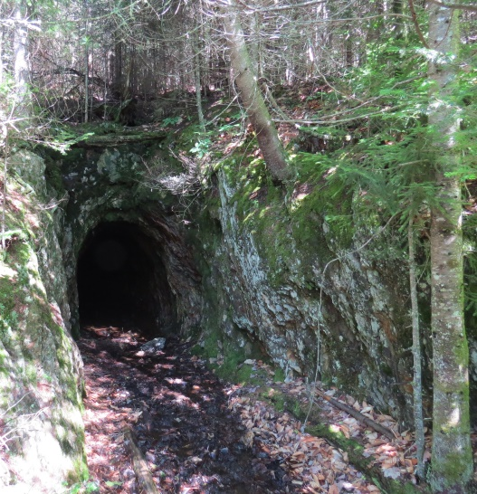
Construction:
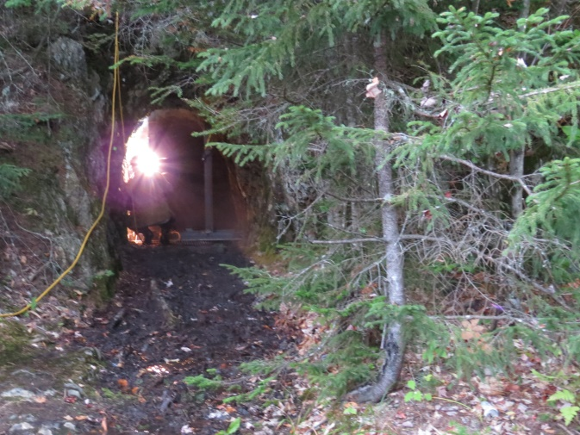

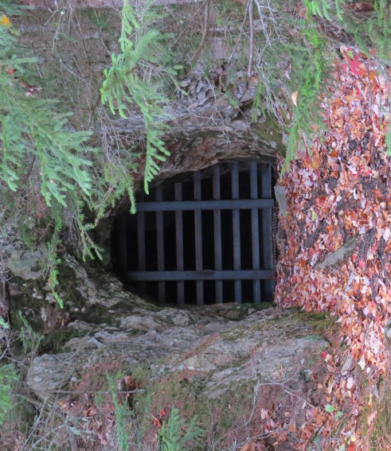
With a new gate installed at this mine last fall, threatened and endangered bats have a place to hibernate without disturbance. Additional Photos and videos available here: https://www.dropbox.com/sh/ztduzt9yvjilbtb/AACuP99BpByjEMgGyWoUSL4la?dl=0

